- Write a program to access parent class variable.
class sample
{
int a=10;
void display()
{
System.out.println("A="+a);
}
}
class sample1 extends sample
{
int a=15;
void display()
{
System.out.println("A="+a);
}
}
class sample2 extends sample1
{
int a=20;
void display()
{
System.out.println("A="+super.a);
}
}
class test
{
public static void main(String args[])
{
sample s=new sample();
sample1 s1=new sample1();
sample2 s2=new sample2();
s.display();
s1.display();
s2.display();
}
}
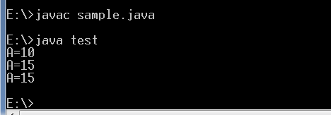

- Write a program to access parent class method.class
sample
{
int a=10;
void display()
{
System.out.println("A="+a);
}
}
class sample1 extends sample
{
int a=15;
void display()
{
super.display();
System.out.println("A="+a);
}
}
class sample2 extends sample1
{
int a=20;
void display()
{
super.display();
System.out.println("A="+a);
}
}
class test
{
public static void main(String args[])
{
sample s=new sample();
sample1 s1=new sample1();
sample2 s2=new sample2();
s2.display();
}
}
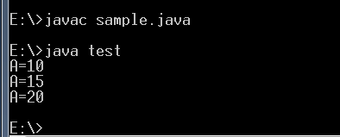

- Write a program to access parent class constructor.
class sample44
{
int a=20;
sample44(int a)
{
super();
System.out.println("A="+a);
}
}
class sample extends sample44
{
int a=10;
sample()
{
super(14);
System.out.println("A="+a);
}
}
class sample1 extends sample
{
int a=15;
sample1()
{
super();
System.out.println("A="+a);
}
}
class sample2 extends sample1
{
int a=20;
sample2()
{
super();
System.out.println("A="+a);
}
}

class test
{
public static void main(String args[])
{
sample2 s2=new sample2();
}
}
